2019 5th International Conference on Advanced Computing & Communication Systems (ICACCS)

FACE RECOGNITION BASED NEW GENERATION ATM MACHINE

D.Arun Kumar UG student, EEE dept,

Sri Krishna College Of Technology, Tamilnadu, India [15tuee019@skct.edu.in](mailto:15tuee019@skct.edu.in)

B.Iniyan

UG student, EEE Dept,

Sri Krishna College Of Technology, Tamilnadu, India [15tuee054@gmail.com](mailto:15tuee054@gmail.com)

M.Ahamed Askar UG Student, EEE Dept,

Sri Krishna College Of Technology, Tamilnadu, India [15tuee003@skct.edu.in](mailto:15tuee003@skct.edu.in)

A.Ajay

UG Student, EEE Dept,

Sri Krishna College Of Technology, Tamilnadu, India [15tuee004@skct.edu.in](mailto:15tuee004@skct.edu.in)

R.Ambika Associate Professor,

Sri Krishna College Of Technology, Tamilnadu, India [r.ambika@skct.edu.in](mailto:r.ambika@skct.edu.in)

***Abstract***

# Programmed acknowledgement of people has Introduction:

**been a testing errand since quite a while and no such adaptable and powerful framework has been planned so far that could give total human acknowledgement access and security to critical data and physical assets among the different acknowledgement strategies have advanced essentially in the most recent decade and develop to a promising region to distinguish people be that as it may, the dependability of face acknowledgement strategies still require testing assignments to be performed by the exploration network to build up a profoundly Vigorous framework by defeating conceivable facial appearance variety .In this paper, we present a biometric based framework known as face acknowledgement calculation consequently hand off will be on ,and engine pivots shows as entry way shutting. This application is process in ATM security framework to improve the verification strategies to improve the innovation.**

**Catchphrases: Arduino, Relay, GSM modem, Dc motor, Camera, Haarcascade**

Face Recognition is an application to naturally distinguish an individual in the wake of contrasting and a database of pictures. A test picture is taken with the assistance of a camera from a still source or video outline, and in the wake of representing different conceivable face appearance varieties, is contrasted and the database pictures for character. Analysis have an extraordinary enthusiasm for this field for its applications in different spaces. One of the business utilizations of the face acknowledgement frameworks could be begin with little essential login applications and prompting the improvement of a high security get to control framework, secure biometric based exchange or exceptionally verified observation framework A information and procedure acclaimed affirm or check the character of an individual or totally security requirements.2 confirmation could be a framework wherever in 2 or a great deal of different elements zone until wont to exhibit the people exploitation higher than issue is ordinarily alluded to as “Solid Confirmation”. The technique for numerous responses to challenge inquiries similarly you as recovers ‘something you have’ or ‘something you are’ is taken into thought multifaceted.

978-1-5386-9533-3/19/$31.00 ©2019 IEEE

938

# Proposed System:

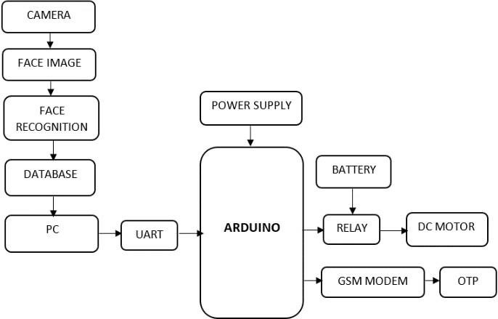

**Fig: Block diagram ]=–ATM Security system Arduino**

As we'll find in a minute, the picture sensor and its hardware changes over the image before the camera into digital format

a series of ones that a PC realizes how to deal with. In contrast to an advanced camera, webcam has no constructed in memory chip or flash memory card: it doesn’t have to “recall” pictures since it’s intended to catch and transmit promptly to a PC. That is the reason webcams have USB links returning out of the. The USB have USB link supplies capacity to the webcam from the PC and takes the advanced data caught by the webcam’s picture sensor back to the PC.

The Arduino Uno is a microcontroller board dependent on the ATmega 328. It has advanced info/yield (of which 6 can be utilized as PWM yields), 6 simple information sources, a 16 MHz earthenware resonator, a USB association , a power jack, an ICSP header, and a reset catch. It contains everything expected to help the microcontroller; essentially interface it to a PC with a USB link or power it with a AC-to-DC Connector or battery to begin . The arduino microcontroller is a simple to utilize yet incredible single board PC that has increased extensive footing in the leisure activity and expert market. The Arduino/Genuino Uno Genuino board when its utilizing an outside power source. You can simply voltage through this

stick, or if voltage supplies through the power stick, or if

voltage supplies through the power jack , get to it through this pin.5V-this stick directs the yield 5V from the controller on the board. The board can be provided with the power either from the DC control hack (7-12), USB board (7-12Volt). Providing voltage by means of and can harm your board. We don’t exhort it. 3V3, A 3.3 volt supply created by the on- board controller.

# Camera- Image sensor

A webcam is a minimal advanced cameras you can connect to your PC to communicate video pictures continuously (as they occur). Much the same as an advanced camera, it catches light through a small lens at the front utilizing a little lattice of infinitesimal light identifiers incorporated with a picture detecting microchip (either a **charge-coupled device** (CCD) or, more probable nowadays, a **CMOS picture sensor**).

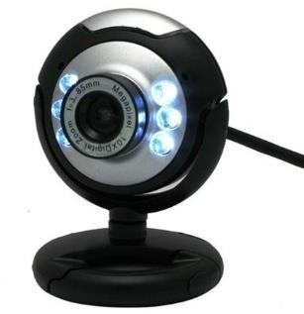

# Fig: Web camera Image Sensor

As we'll see find in a minute, the picture sensor and its hardware changes over the before the camera into digital format a series of ones that a PC realizes how to deal with. In contrast **to a computerized camera, a webcam has no assembled in memory chip or flash memory card: it doesn’t have to “recollect**” **pictures since it’s intended to catch and transmit them promptly to a PC. That is the reason webcams have USB link supplies capacity to the**

# webcam from the PC and takes the advanced data caught by the webcam’s picture sensor back to PC.

**UART:**

939

UART represents Universal Asynchronous Receiver/Transmitter. It is the anything but a communication protocol like SPI and 12C, yet a physical circuit in microcontroller, or an independent IC. A UART’s principle design is to transmit and get sequential information.

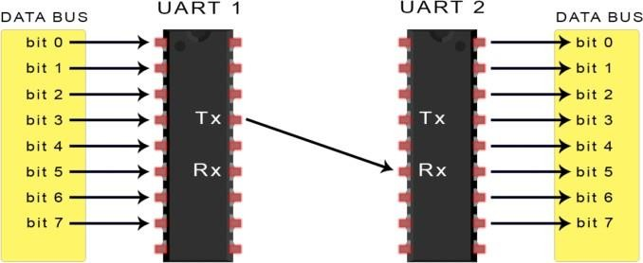

# Fig: UART- Universal Asynchronous Receiver Transmitter

A standout amongst the best things about UART is that it just uses two wires to transmit information between devices. The standards behind UART are straight forward , yet one of this series, Basics of the SPI Communication Protocol, that may be a decent spot to begin. The UART that will transmit information gets the information from an information transport. The information transport is utilized to send information to the UART by another device like a CPU, memory, or microcontroller ,information is exchanged from the information bus to the transmitting UART the parallel information from the information transport, and a stop bit, making the information parcel. Next, the information parcel is yield

Sequentially a little bit at a time at the Tx stick. The accepting UART peruses the information parcel a little bit at a time at its Rx stick. The accepting UART then changes over the Information once again into parallel form and removes the begin fit, equality bit and stop bits.

# GSM MODEM:

A GSM modem is the unique kind of modem which acknowledges a SIM card, and works over a membership to a versatile administrator, much the same as cell phone. With the end goal of this archive, the term Global System for Mobile Communication modem is utilized as a Conventional term to allude to any modem that underpins at least one of the

conventions in the GSM transformative family, including the 2.5G advancement GPRS and EDGE, just as the 3G advances like WCDMA,UMTS,HSDPA and HUSA.A GSM modem communicate an interface that permits applications, for example, SMS to send and gets the messages over the modem interface .To play out these assignments, a GSM modem must help a “reached out AT order set” for sending/accepting

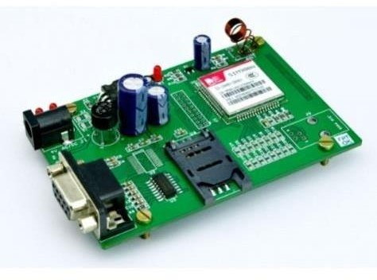

# Fig: GSM MODEM

SMS. In most pieces of the world, GSM modems are financially savvy answer for getting SMS, in light of the fact that the sender is paying for the message delivery. A GSM Modem can be utilized to commit the modem gadgets with a sequential, USB or Bluetooth association, for example, the light-weight, remote modem that gives EDGE,GPRS and GSM availability for convenient ,handled PCs and others. To start ,embed a GSM SIM CARD into the modem and associate it to an accessible USB port on your PC.

# Personal computer (PC):

A PC is universally useful PC whose size, abilities, and for unique deals value make it helpful for clients and which is worked specifically by a finish of the client with no intercession PC administrator. This is as opposed to the group handling or time-sharing models which enabled expansive costly centralized server frameworks to be utilized by numerous individuals, for the most part in the meantime, or a vast information preparing the frameworks which required a full-time staff to work proficiently PC might be a personal computer, a PC, a tablet PC, or a handled PC (likewise called a playtop). PCs have associations with the Internet ,enabling access to the World Wide Web and a wide scope of different

940

access .A PC might be utilized at home or in workplaces. PCs might be associated LAN, either by a link or a remote association. While early PC proprietors typically needed to compose their very own projects to do anything helpful with the machines, the present clients need to get to a wide scope of business and nom-business programming, which is given in prepared to –run or prepared to-accumulate structure.

# Relay and Motor:

The DPDT relay or handoff (Double Pole Double Throw) is very fascinating and can be utilized in different situations, including for altering the course o an engine as should be obvious in the course of the engine as should be obvious in the image underneath. It has 2 terminals and 4 connectors and you can take a ground at the DPDT relay as what might be compared to 2 Single Pole Double Throw SPDT transfers between the control circuit and the circuit being controlled

# Fig: DPDT Relay with Motor

.

A relay typically has five pins:

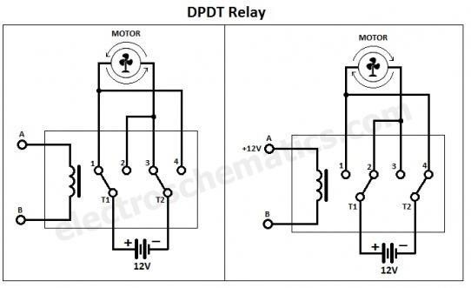

1. Coil input pin1. This is commonly associated with the positive terminal of your flag source
2. Coil input pin2. This is commonly associated with the negative terminal of your signal source.
3. Typically Open pin. This stick is ordinary not associated with the regular stick ,it is associated when the transfer is activated.
4. Ordinarily shut pin . This stick is typically associated with the regular stick and it is removed when the relay is started.
5. In many of the cases, this stick is associated with the ground of the source we use to drive the apparatus.

# Haar Cascade Classifier Recognition Method for Face:

It is an AI based technology where a course work is prepared from a great deal of positive and a negative pictures. It is then used to distinguish protest in different images. Here we all work with face recognition .First of it the calculation needs a great deal of positive and negative images to prepare the classifier. At the point they have to extricate highlights from it. For this, hear highlights appeared underneath image are utilized. They are similar to our convolutional region .Every element is solitary esteem gotten by reducing whole of pixels under white square shape from total of pixels under dark square shape.

# Features:-

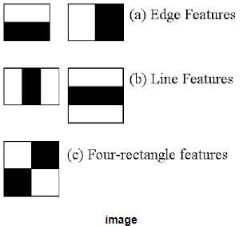

* Presently all possible sizes and shapes of every pieces utilized to calculate a lot of highlights. (simply envision what amount of calculation it needs?)

941

* + Indeed even a 24x24 window results over than 16000 highlights ). Or each component computation.We have to discover total of pixels under white and dark square shapes.
  + To solve this, they presented the necessary images. It streamlines figuring o whole pixels.
  + how large might be the quantity of pixels, to a task including only four pixels. Decent, would it sat isn’t? It make things super fast
  + However, every one of these highlights we determined

,a large of them are useless

* + The principle include chose appears to concentrate on the property that the local of the eyes is regularly darker than nose in the cheeks.
  + The Second element chose depends on the property that eyes are darker than the scaffold of the nose.
  + For instance ,considered the picture underneath top line demonstrates two grade highlights.
  + Be that as it may, similar windows applying on cheeks are some others part in material .so how would we select the best highlights out of 16000+ highlights? It is accomplished by adaboost.

# Models:-

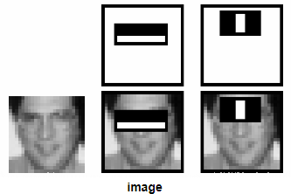

For this, we apply every single component on all the preparation pictures. For each element, it finds the best limit which will order the appearance to positive and negative.

Be that as it may clearly there will be mistakes. We select the highlights with least mistake rate, which implies they are the highlights that best groups the face and non face pictures The procedure isn’t as straightforward as this each picture is given an equivalent load first and foremost. After every order, lots of misclassified pictures are expanded. Of course same procedure is completed .

New mistake rates are determined likewise new loads .The procedure is proceeded until required precision or mistake rate is accomplished or required number of highlights are found. Last classifier is a weighted whole of this frail classifiers. It is called frail since only it can order the picture, however the paper says even 200 highlights furnish location with 95% accuracy. Their last setup add around 6000 highlights (envision a decrease from 16000 highlights to 6000 highlights. That is a major addition)

For this they presented the idea of **Cascade Classifiers**. Rather than applying all the 6000 highlights on the window, aggregate the highlights into various phases of classifier and apply one by one. (Regularly initial couple of stages will contain less number of highlights).

* + One of the chance that a window fizzles the main stage, dispose of it.

942

2019 5th International Conference on Advanced Computing & Communication Systems (ICACCS)

* + We don't think about residual highlights on it. on the off chance that it passes, apply all the second phase of the highlights and proceed with the procedure.
  + The second phase of the elements happens and recognizes the phase.
  + On the off chance the result is positive, the process continues.
  + Third stage happens depends upon the geometrical elements of the face to be perceived.
  + In the event that all the above stages are sure, at the point the outcome would be sure the client is permitted to take cash and the procedure ends .

# Software description

1. Installing Arduino IDE:

The Arduino IDE keeps running on all the most reason renditions of the Microsoft windows. To download the most up to date form of the IDE from the download page get to the arduino site www.arduino .cc. In the Arduino IDE new forms of the windows IDE are accessable as an installer that we can download and run, rather than downloading a ZIP record. Introduce drivers or the Arduino USB port and this procedure relies upon the Aduino board. After the drivers have been introduced, begin the executable rom the documents undamentak index by double tapping on it.

# Arduino UNO Programming:

The Arduino board can be modified utilizing the Arduino IDE programming. The publications window will open when the Arduino IDE programming is opened.This window accepts o two critical parts, one is setup part and second is the proinciple circle. The Arduino ports, or example, ino yield, and consistent capacities are characterized in setup part and circling conditions are coded in the principle circle.At the point the program is assembled or blunders and alerts. On fruitiul investigating, the code is inserted to the controller through the transfer choice.

# Conclusion:

This paper has exhibited the adequacy of ace recognition framework perceiving aces utilizing a view based methodology actualized with Haarcascade. Haar course based ace acknowledgement is vigorous and has better execution. Also combination of various Haar execution. Also combination o various Haar chose organizes classifiers improves the general execution o ace acknowledgement. Joined with other open CV with the Haar course organizes strategies, this strategy gives better outcomes and acknowledgement rate is expanded. Further research is conceivable to expand execution issues and estimation and correlations of different calculations as portrayed in the displayed structure

# References

* 1. H. Anandakumar and K. Umamaheswari, “Supervised machine learning techniques in cognitive radio networks during cooperative spectrum handovers,” Cluster Computing, vol. 20, no. 2, pp. 1505– 1515, Mar. 2017.
  2. Roshini and H. Anandakumar, “Hierarchical cost effective leach for heterogeneous wireless sensor networks,” 2015 International Conference on Advanced Computing and Communication Systems, Jan. 2015.
  3. H. Anandakumar and K. Umamaheswari, “An Efficient Optimized Handover in Cognitive Radio Networks using Cooperative Spectrum Sensing,” Intelligent Automation & Soft Computing, pp. 1–8, Sep. 2017.
  4. M. Suganya and H. Anandakumar, “Handover based spectrum allocation in cognitive radio networks,” 2013 International Conference on Green Computing, Communication and Conservation of Energy (ICGCE), Dec. 2013.
  5. H. Anandakumar and K. Umamaheswari, “A bio-inspired swarm intelligence technique for social aware cognitive radio handovers,” Computers & Electrical Engineering, vol. 71, pp. 925–937, Oct. 2018.
  6. Anandakumar, “Energy Efficient Network Selection Using 802.16g Based Gsm Technology,” Journal of Computer Science, vol. 10, no. 5, pp. 745–754, May 2014.

943